Date/Time Transformation

Definition
# Source: AI Source: Provided by: [Data Path: Persons Table -> ID Column: 1, Name_En Column: Motasem Essam] -> From: [Chatgpt (GPT‑5 Mini)] on [12/10/2025]
Date/Time Transformation is a data preprocessing technique that converts date and time values into numerical or structured features that can be used in data analysis and machine learning models.
Raw date and time values are often difficult for algorithms to process directly, so they are transformed into meaningful numerical components.

Key Idea
# Source: AI Source: Provided by: [Data Path: Persons Table -> ID Column: 1, Name_En Column: Motasem Essam] -> From: [Chatgpt (GPT‑5 Mini)] on [12/10/2025]
Date and time values are broken into smaller components such as:
- Year
- Month
- Day
- Hour
- Minute
- Day of the week
These features help models identify time-based patterns and trends.

Common Date/Time Transformations

1. Extracting Date Components
# Source: AI Source: Provided by: [Data Path: Persons Table -> ID Column: 1, Name_En Column: Motasem Essam] -> From: [Chatgpt (GPT‑5 Mini)] on [12/10/2025]
A date can be split into multiple useful attributes.
Example:
Original value:
Order Date
2024-05-18
After transformation:
Year | Month | Day
2024 | 5 | 18

2. Extracting Time Components
# Source: AI Source: Provided by: [Data Path: Persons Table -> ID Column: 1, Name_En Column: Motasem Essam] -> From: [Chatgpt (GPT‑5 Mini)] on [12/10/2025]
Example:
Timestamp
2024-05-18 14:35:20
After transformation:
Hour | Minute | Second
14 | 35 | 20

3. Day of Week Extraction
# Source: AI Source: Provided by: [Data Path: Persons Table -> ID Column: 1, Name_En Column: Motasem Essam] -> From: [Chatgpt (GPT‑5 Mini)] on [12/10/2025]
Example:
Date | Day of Week
2024-05-18 | Saturday
This can also be encoded numerically:
Date | Day_Number
2024-05-18 | 6

4. Duration or Time Difference
# Source: AI Source: Provided by: [Data Path: Persons Table -> ID Column: 1, Name_En Column: Motasem Essam] -> From: [Chatgpt (GPT‑5 Mini)] on [12/10/2025]
Calculate the difference between two dates.
Example:
Start Date | End Date | Duration (Days)
2024-05-01 | 2024-05-10 | 9

Example
# Source: AI Source: Provided by: [Data Path: Persons Table -> ID Column: 1, Name_En Column: Motasem Essam] -> From: [Chatgpt (GPT‑5 Mini)] on [12/10/2025]
Original dataset:
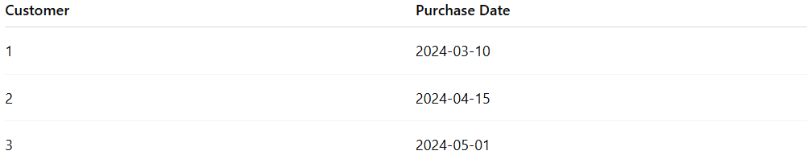
Customer | Purchase Date
1 | 2024-03-10
2 | 2024-04-15
3 | 2024-05-01
After transformation:
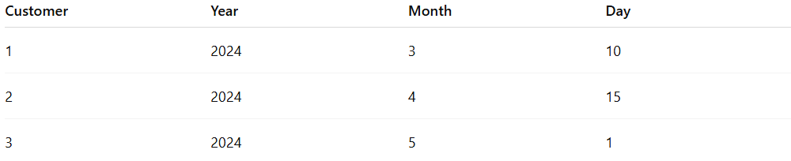
Customer | Year | Month | Day
1 | 2024 | 3 | 10
2 | 2024 | 4 | 15
3 | 2024 | 5 | 1

Advantages
# Source: AI Source: Provided by: [Data Path: Persons Table -> ID Column: 1, Name_En Column: Motasem Essam] -> From: [Chatgpt (GPT‑5 Mini)] on [12/10/2025]
- Helps identify time-based trends and seasonality
- Improves model performance by extracting meaningful temporal features
- Makes date/time data easier for algorithms to process

Disadvantages
# Source: AI Source: Provided by: [Data Path: Persons Table -> ID Column: 1, Name_En Column: Motasem Essam] -> From: [Chatgpt (GPT‑5 Mini)] on [12/10/2025]
- Can increase the number of features in the dataset
- Some temporal relationships may still require advanced feature engineering

Date/Time Transformation vs Date-Time Format Standardization
# Source: AI Source: Provided by: [Data Path: Persons Table -> ID Column: 1, Name_En Column: Motasem Essam] -> From: [Chatgpt (GPT‑5 Mini)] on [12/10/2025]
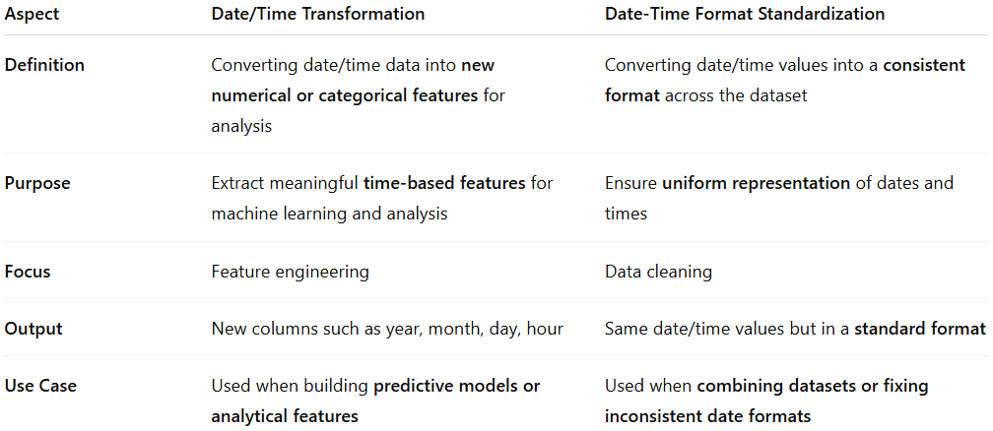
Date/Time Transformation vs Date-Time Format Standardization
Although both techniques deal with date and time data, they serve different purposes in data preprocessing.
Aspect | Date/Time Transformation | Date-Time Format Standardization
Definition | Converting date/time data into new numerical or categorical features for analysis | Converting date/time values into a consistent format across the dataset
Purpose | Extract meaningful time-based features for machine learning and analysis | Ensure uniform representation of dates and times
Focus | Feature engineering | Data cleaning
Output | New columns such as year, month, day, hour | Same date/time values but in a standard format
Use Case | Used when building predictive models or analytical features | Used when combining datasets or fixing inconsistent date formats

1. Date/Time Transformation
# Source: AI Source: Provided by: [Data Path: Persons Table -> ID Column: 1, Name_En Column: Motasem Essam] -> From: [Chatgpt (GPT‑5 Mini)] on [12/10/2025]
Example
Original data:
Order Date
2024-05-18
After transformation:
Year | Month | Day
2024 | 5 | 18
The date is broken into multiple useful components for analysis.
Other transformations may include:
- Day of week
- Quarter of year
- Time differences between dates
- Hour or minute from timestamps

2. Date-Time Format Standardization
# Source: AI Source: Provided by: [Data Path: Persons Table -> ID Column: 1, Name_En Column: Motasem Essam] -> From: [Chatgpt (GPT‑5 Mini)] on [12/10/2025]
Example
Original dataset with inconsistent formats:
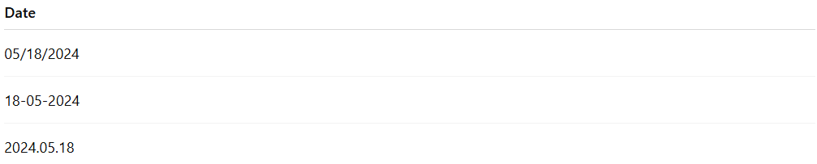
Date
05/18/2024
18-05-2024
2024.05.18
After standardization:
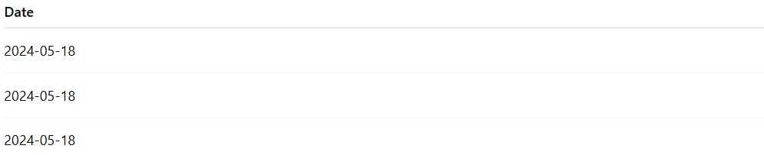
Date
2024-05-18
2024-05-18
2024-05-18
The values stay the same logically, but the format becomes consistent.
Common standardized formats include:
- YYYY-MM-DD (ISO standard)
- YYYY-MM-DD HH:MM:SS for timestamps

Key Difference
# Source: AI Source: Provided by: [Data Path: Persons Table -> ID Column: 1, Name_En Column: Motasem Essam] -> From: [Chatgpt (GPT‑5 Mini)] on [12/10/2025]
- Date-Time Standardization → fixes how dates are written
- Date/Time Transformation → creates new features from dates

Simple Analogy
# Source: AI Source: Provided by: [Data Path: Persons Table -> ID Column: 1, Name_En Column: Motasem Essam] -> From: [Chatgpt (GPT‑5 Mini)] on [12/10/2025]
If a date is "2024-05-18 14:30":
- Standardization → convert it to a consistent format like
2024-05-18 14:30:00
- Transformation → extract useful parts like:
Year | Month | Day | Hour
2024 | 5 | 18 | 14

✅ In short:
# Source: AI Source: Provided by: [Data Path: Persons Table -> ID Column: 1, Name_En Column: Motasem Essam] -> From: [Chatgpt (GPT‑5 Mini)] on [12/10/2025]
- Standardization = formatting the date
- Transformation = extracting useful information from the date.

